**User Manual**

**Homepage**

### Overview:

The homepage is designed to be the first land page of the application. The page on contains clickable buttons in the navigation menu. The details of each navigation option are described below in the *Navigation Menu* section

**Navigation Menu:**



1. Home:

* **Description**: Navigate back to the main homepage.
* **How to Use**: Click on the "Home" tab.

2. Accident Info:

* **Description**: Access detailed accident reports and relevant data.
* **How to Use**: Click on the "Accident Info" tab.

3. Map:

* **Description**: View a map representation of accident locations.
* **How to Use**: Click on the "Map" tab.

**Graph Generation Tools:**

### Overview:

The "Accident Info" page is designed to visualize accident data based on user-selected criteria. This powerful tool provides insights by graphically representing accident occurrences based on type, date, alcohol relation and time of day.

1. Accident Types:

* **Description**: Select the type of accidents you wish to include in the graph.
* **How to Use**: Check the boxes corresponding to the desired accident types.

2. Date Select:

* **Description**: Choose a specific date or date range for which you want accident data.
* **How to Use**: Click on the date box and select a date from the calendar drop-down. If selecting a range, repeat this for both start and end dates.

3. Alcohol Related:

* **Description**: Filter the data based on whether the accident was alcohol-related.
* **How to Use**: Check the "Alcohol Related?" box to only include accidents where alcohol was a factor.

4. Type of Accident or Time of Day:

* **Description**: Specify if you wish to segment the data based on the type of accident or the time of day the accident occurred.
* **How to Use**: From the drop-down menus, choose the desired type of accident or time of day.

5. Clear:

* **Description**: Reset all selection criteria to their default settings.
* **How to Use**: Click on the "Clear" button.

6. Generate Report:

* **Description**: Create a visual representation (graph) based on the selected criteria.
* **How to Use**: After selecting your desired criteria, click on the "Generate Report" button.

### Map Tool

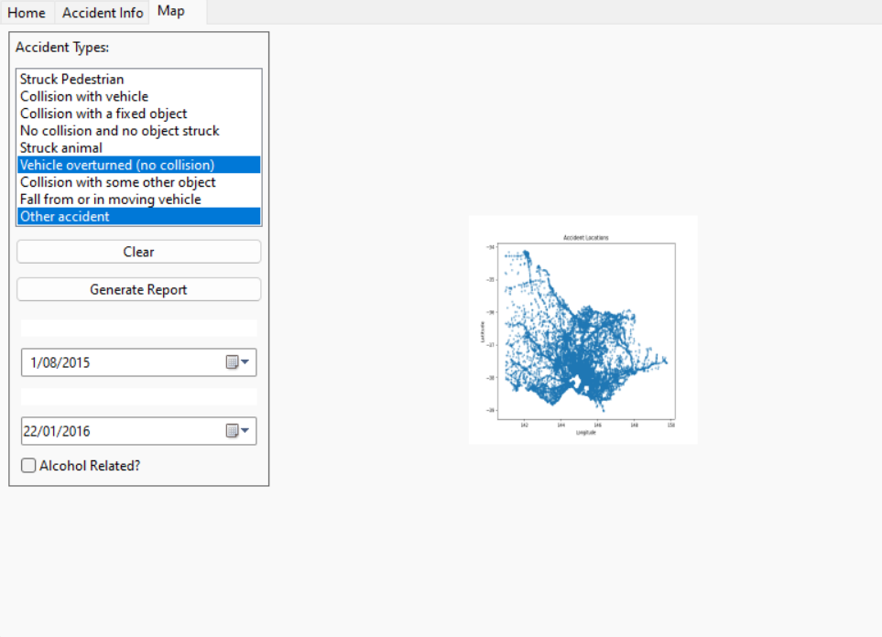

### Overview:

The "Map Page" is designed to offer a visual representation of accident locations in Victoria, Australia. Users can filter accident data based on specific criteria and view the spatial distribution of accidents on a map.

1. Accident Map:

* **Description**: A map highlighting accident locations in Victoria, Australia.
* **How to Use**: Navigate the map by clicking and dragging. Zoom in/out using the scroll wheel or pinch gestures on touch devices.

2. Accident Types:

* **Description**: Select the type of accidents you wish to include in the graph.
* **How to Use**: Check the boxes corresponding to the desired accident types.

3. Date Select:

* **Description**: Choose a specific date or date range for which you want accident data.
* **How to Use**: Click on the date box and select a date from the calendar drop-down. If selecting a range, repeat this for both start and end dates.

4. Alcohol Related:

* **Description**: Filter the data based on whether the accident was alcohol-related.
* **How to Use**: Check the "Alcohol Related?" box to only include accidents where alcohol was a factor.

5. Clear:

* **Description**: Reset all selection criteria to their default settings.
* **How to Use**: Click on the "Clear" button.

6. Generate Report:

* **Description**: Create a visual representation (graph) based on the selected criteria.
* **How to Use**: After selecting your desired criteria, click on the "Generate Report" button.